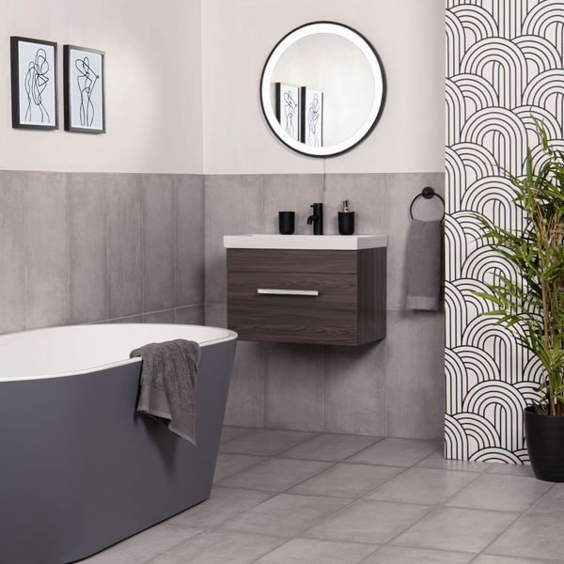**Samphire Matt Grey Tiles:**

## **Product Description**

With a classic design that’s perfectly suited to any indoor space, our Samphire Dark Grey Stone Effect Porcelain Tiles are the perfect choice for your home. Made from durable porcelain, they feature a mottled stone effect design that embodies the modern, yet rustic feel that’s so popular in interior design. The tiles’ textured surface and natural matt finish are reminiscent of natural stone, forming a simple, elegant look in your home that’s made to last.

**What’s special about these tiles?**

> Dark grey hue

> Naturalistic textured surface

> Durable and hardwearing

> Long lasting and easy to clean

## **Product Info**

* Product ID 45696
* Tiles Per SQM 5.6115463177033
* Sale by Per SQM
* Size 298x598x8mm
* Weight 3.30 KG
* Material Type Porcelain
* Finish Matt
* Colour Grey
* Suitability Floors, Walls
* Area Of Usage Internal, External
* Grade 4
* Rectified Edge No
* Underfloor Heating Yes
* Thickness (mm) 8